**GAUSS’ LAW**

**Electric Flux (Φ)**

****Electric flux is the measure of flow of the electric field through a given area. It is proportional to the number of electric field lines going through a normally perpendicular surface.

***Flux of a Uniform Electric Field***

Consider first a flat area perpendicular to a uniform electric field. We define the electric flux through this area to be the product of the field magnitude ***E***and the area ***A***:

**Φ = EA**

If a constant field is at an angle Ø from the normal to the surface, then the flux is given by:

**  EAcos**Ø

Since EcosØ is the component of perpendicular to the area, we can rewrite the equation as

**  E ﬩ A**

Gauss’ law relates the net flux **Φ** of an electric field through a closed surface (a Gaussian surface) to the *net* charge qenc that is *enclosed* by that surface. It tells us that

***The total electric flux through a closed surface is equal to the total (net) electric charge inside the surface, divided by $ε_{0}$.***

$$Φ=\frac{q_{enc}}{ε_{0}} (Gauss^{'}Law)$$

The constant $ε_{0}$ is called the permittivity of free space and has the value **8.85 x 10-12 C2/N.m2**.

*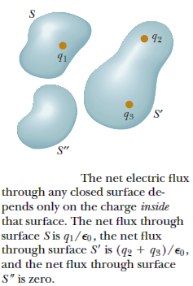Consider the figure below:*

The net electric flux through any closed surface depends only on the charge inside that surface. The net flux through surface S is q1/, the net flux through surface S’ is (q2+q3)/, and the net flux through surface S” is zero.

**Applications of Gauss’ Law**

Gauss’ Law is a powerful technique to calculate the electric field for situations exhibiting a high degree of symmetry.

1. ***Infinite Sheet of Charge***

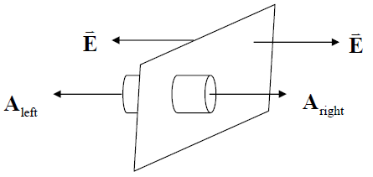Let’s calculate the electric field from an infinite sheet of charge, with a charge density of **σ = qenc/A** (measured in C/m2).

Now consider a closed surface (which we will call a Gaussian surface) that extends through the sheet of charge. The sides, here assumed cylindrical, are chosen to be perpendicular to the sheet. So ***EA***side = 0. The caps are parallel to the sheet, so ***EA****left* = ***EA****right* since both vectors always point in the same direction. The total flux through the surface is thus:

Φ **=** *EAleft* + *EAright* = 2*EA*

By Gauss’ Law, Φ = $\frac{q_{enc}}{ε_{0}}$, where qenc = σA. So: Φ = 2*EA* = $\frac{σA}{ε_{0}}$

$$E=\frac{σ}{{2ε}_{0}}= \frac{q_{enc}}{2ε_{0}A}$$

# ***Infinite Line of Charge***

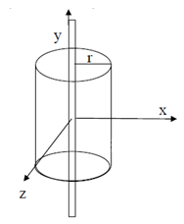Let’s calculate the electric field a distance *r* from a line of electric charge infinite in extent with charge density **λ=qenc/L** (measured in C/m).

Choose a Gaussian surface with cylindrical geometry, with top and bottom caps aligned such that their area vectors point in the same direction as the line of charge (and perpendicular to the electric field): **EAtop = EAbottom = 0**.

So the total flux leaves through the sides:

$$Ф = EA=E(2πrL)$$

since |E| is constant at a fixed radius. Thus Ф = $E\left(2πrL\right)$ = $\frac{q_{enc}}{ε_{0}}$ = $\frac{λL}{ε_{0}}$

$$E= \frac{λ}{{2πε}_{0}r}=\frac{q_{enc}}{2πε_{0}rL}$$

## ***Spheres of Charge***

1. ***Shell and Conducting Solid Sphere***
2. Let’s calculate the electric field ***outside a spherically charged shell or conducting solid sphere***.

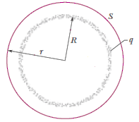The radius of the sphere is *R*. A total charge qenc is spread uniformly on the surface, so the charge density per unit area is σ = $\frac{q_{enc}}{V}$ = $\frac{q_{enc}}{4πR^{2}}$ (measured in C/m3).

For our Gaussian surface choose another sphere with radius r > R , centered on the charged sphere.

Since |**E|** is constant at a fixed radius, the total flux through the surfce is:

$$Ф=EA=E\left(4πr^{2}\right)=\frac{q_{enc}}{ε_{0}}=\frac{σ(4πR^{2})}{ε_{0}}$$

$$E= \frac{q_{enc}}{{4πε}_{0}r^{2}}=\frac{σR^{2}}{ε_{0}r^{2}}$$

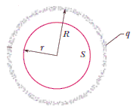The situation changes for the electric field ***inside a spherical shell or conducting solid sphere.***

For r < R, then there is no net enclosed charge, and ***E = 0.*** No force acts on any point charge placed anywhere inside a charged shell (forces from all infinitesimal charges in the shell balances).

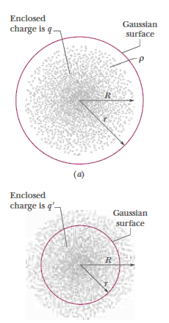

***Uniformly Charged Solid Insulating (Nonconducting) Sphere.***

For the electric field ***outside***a solid sphere of total charge *Q*,

**E = $\frac{Q}{{4πЄ}_{0}r^{2}}$**

For the electric field ***inside***a solid sphere of total charge *Q*, then there is a net enclosed charge. First assume that the total charge of a solid sphere is spread uniformly throughout its volume. The volume charge density is therefore:

ρ = $\frac{Q}{\frac{4}{3}πR^{3}}$ (measured in C/m3).

The charge enclosed for r < R is qenc = ρ πr3 = Q

So Gauss’ Law tells us that Ф = = E(4πr2) =

**E = *r***

**Electric field of various symmetric charge distributions:** The following table lists electric fields caused by several symmetric charge distributions. In the table, *q*, *Q*, λ, and σ refer to the *magnitudes* of the quantities.

|  |  |  |
| --- | --- | --- |
| **Charge Distribution** | **Point in Electric Field** | **Electric Field Magnitude** |
| Single point charge q | Distance r from q | **E = $\frac{q}{{4πЄ}_{0}r^{2}}$** |
| Infinite sheet of charge with uniform charge per unit area σ | Any point | **E = $\frac{σ}{{2Є}_{0}}$** |
| Infinite wire, charge per unit length λ | Distance r from wire | **E = $\frac{λ}{{2πЄ}_{0}r}$** |
| Charge q on surface of ***conducting sphere*** with radius R | Outside sphere, r > R  Inside sphere, r < R | **E = $\frac{q}{{4πЄ}_{0}r^{2}}$**  **E = 0** |
| ***Solid insulating sphere*** with radius R, charge Q distributed uniformly throughout volume | Outside sphere, r > R  Inside sphere, r < R | **E = $\frac{Q}{{4πЄ}_{0}r^{2}}$**  **E = $\frac{Q}{{4πЄ}_{0}R^{3}}$*r*** |

Problems:

1. A flat sheet of paper of area 0.250 m2 is oriented so that the normal to the sheet is at an angle of 600 to a uniform electric field of magnitude 14N/C. Find the magnitude of the electric flux through the sheet.
2. A flat sheet is in the shape of a rectangle with sides of lengths 0.400 m and 0.600 m. The sheet is immersed in a uniform electric field of magnitude 75 N/C that is directed at 200 from the plane of the sheet. Find the magnitude of the electric flux through the sheet.



1. You measure an electric field of 1.25 x 106 N/C at a distance of 0.150 m from a point charge. There is no other source of electric field in the region other than this point charge. (a) What is the electric flux through the surface of a sphere that has this charge at its center and that has radius 0.150 m? (b) What is the magnitude of this charge?
2. The three small spheres shown in carry charges q1 = 4nC, q2 = -7.8nC, and q3 = 2.4nC. Find the net electric flux through each of the following closed surfaces shown in cross section in the figure: (a) S1; (b) S2; (c) S3; (d) S4; (e) S5.



1. A charged paint is spread in a very thin uniform layer over the surface of a plastic sphere of diameter 12.0 cm, giving it a charge of -35µC. Find the electric field (a) just inside the paint layer; (b) just outside the paint layer; (c) 5.00 cm outside the surface of the paint layer.
2. A point charge q1 = 4nC is located on the x-axis at x = 2m, and a second point charge q2 = -6nC is on the y-axis at y = 1m. What is the total electric flux due to these two point charges through a spherical surface centered at the origin and with radius (a) 0.500 m, (b) 1.50 m, (c) 2.50 m?
3. A solid metal sphere with radius 0.450 m carries a net charge of 0.250 nC. Find the magnitude of the electric field (a) at a point 0.100 m outside the surface of the sphere and (b) at a point inside the sphere, 0.100 m below the surface.
4. The electric field at a distance of 0.145 m from the surface of a solid insulating sphere with radius 0.355 m is 1750 N/C. (a) Assuming the sphere’s charge is uniformly distributed, what is the charge density inside it? (b) Calculate the electric field inside the sphere at a distance of 0.200 m from the center.
5. The electric field 0.400 m from a very long uniform line of charge is 840 N/C. How much charge is contained in a 2.00-cm section of the line?
6. A solid metal sphere of radius 3.00 m carries a total charge of -5.50µC. What is the magnitude of the electric field at a distance from the sphere's center of (a) 0.250 m, (b) 2.90m, (c) 3.10m, and (d) 8.00m? How would the answers differ if the sphere were (e) a thin shell, or (f) a solid nonconductor uniformly charged throughout?
7. A long thin wire, hundreds of meters long, carries a uniformly distributed charge of -7.2µC per meter of length. Estimate the magnitude and direction of the electric field at points (a) 5.0 m and (b) 1.5 m perpendicular from the center of the wire.